# **Vietnam**

Vietnam has rapidly emerged as a promising offshore development destination, driven by a combination of technical expertise, cost efficiency, and a rapidly growing tech ecosystem. The country’s strategic location in Southeast Asia, alongside its strong focus on STEM education, offers strategic opportunities for businesses aiming to scale globally. Three cities - Hanoi, Ho Chi Minh City (HCMC), and Da Nang - are at the heart of this transformation.

**Hanoi**, the capital and home to the "Silicon Valley of Vietnam", is a hub for innovation, with a high concentration of tech talent and government-backed initiatives fostering growth.

**Ho Chi Minh City,** the largest city, serves as the financial and commercial hub, housing many multinational companies and technology startups.

**Da Nang**, a rising star in Vietnam’s tech scene, is known for its rapidly growing IT sector and modern infrastructure, making it an attractive choice for tech-focused businesses.

This guide will explore the strategic benefits and key considerations for choosing Vietnam as an offshore development center, emphasizing its unique advantages for businesses seeking to scale efficiently in the global market.

# **Executive Summary**

## Overview

Vietnam has achieved remarkable milestones in its economic development, becoming one of the fastest-growing economies in Asia. Political stability, consistent macroeconomic policies, and efforts toward international integration have significantly contributed to this progress.

In 2023, Vietnam officially became the third-largest economy in Southeast Asia, following Indonesia and Thailand, with GDP growth of 5.05% - 1.5 times higher than the global growth rate of 2.9%. Total registered foreign direct investment (FDI) in the first five months of 2024 surpassed $11 billion, an increase of 2%, while total import-export turnover grew by 16.6% year-on-year, resulting in a trade surplus of $8.01 billion. With its advantageous geographic location and political stability, Vietnam remains an attractive destination for global investment and cooperation.

Regarding economic growth, the IMF Managing Director described Vietnam as a shining star in the global economy, ranking as the 35th largest economy in the world, with growth double the global average due to prudent and proactive monetary policies. The World Bank (WB) projects GDP growth at 6.3%, while Standard Chartered Bank forecasts a 6.5% increase. Japanese businesses regard Vietnam as the most dynamic economy in Southeast Asia and a key player in the global supply chain, with many Japanese companies choosing Vietnam as their preferred destination for investment relocation.

Vietnam’s Information and Communication Technology (ICT) sector is expanding rapidly, contributing approximately 812,396 billion VND to the nation’s GDP in 2024, positioning it as a key player in the digital economy. On the international stage, in the field of software and IT services, Vietnam consistently ranks among the Top 10 most attractive countries for software outsourcing services. Since 2014, it has been the second-largest partner for the Japanese market. Nearly 40% of the sector's revenue comes from export activities. Major markets include the United States, Japan, and Europe, with rapid expansion into markets such as South Korea, Hong Kong, Singapore, and Australia. Vietnam ranks 7th in the Global Services Location Index (GSLI) by Kearney and 13th among the Top 50 Digital Nations as assessed by Tholons. (Source: VINASA)

## Economic Growth and Political Stability

Vietnam has emerged as one of the most dynamic economies in Asia, consistently maintaining robust growth rates despite global economic challenges. As mentioned above, in 2023, Vietnam officially became the third-largest economy in Southeast Asia, following Indonesia and Thailand, with GDP growth of 5.05% - 1.5 times higher than the global growth rate of 2.9%. This growth has been driven by Vietnam's strong export sector, including high-performing industries like technology, agriculture, and manufacturing. Additionally, Vietnam's strategic location provides businesses with easy access to key markets such as the United States, Japan, and Europe, while also fostering rapid expansion into emerging markets like South Korea, Hong Kong, and Australia. The country’s sound fiscal policies and increasing foreign direct investment (FDI) reinforce its economic stability, making it a compelling choice for businesses looking to establish ODCs.

Equally important to Vietnam’s economic success is its political stability. The country’s consistent governance and long-term policy continuity have provided a stable environment for both local and foreign businesses to thrive. With a one-party political system, Vietnam benefits from centralized decision-making, which has allowed for the swift implementation of economic reforms and the development of long-term strategic initiatives. This political stability, combined with the country’s economic openness and pro-business reforms, makes Vietnam an increasingly attractive destination for offshore expansion, as it offers a secure environment for companies looking to scale and innovate on a global scale.

Vietnam’s proactive approach to international integration through trade agreements and its commitment to fostering a harmonious business climate further enhance its appeal. By reducing bureaucratic hurdles and ensuring streamlined processes for foreign investment, the government has created a conducive environment for businesses to establish ODCs with minimal risks. This reliable and predictable political landscape strengthens Vietnam’s position as a preferred choice for companies seeking sustained growth and innovation in the region.

## Cost Benefits

### Living Standards

The cost of living in Vietnam is significantly lower than in many Western countries, making it a great choice for attracting international talent. Housing, transportation, food, and healthcare costs are more affordable in Vietnam, allowing employees to enjoy a high standard of living at a fraction of the price they would pay in cities like New York, London, or Sydney. This affordability means that companies can attract skilled professionals at a lower wage compared to hiring talent in more expensive markets, while still offering competitive salaries and a comfortable lifestyle. For businesses, this provides a unique opportunity to access top-tier talent, particularly in technology, engineering, and other high-demand sectors, without the high labor costs often associated with Western countries.

Additionally, the lower cost of living enhances employee satisfaction, as they can maintain a good quality of life with lower expenses, further improving retention rates. As a result, Vietnam is increasingly becoming a sought-after destination for companies looking to hire international talent and expand their teams at a lower overall cost.

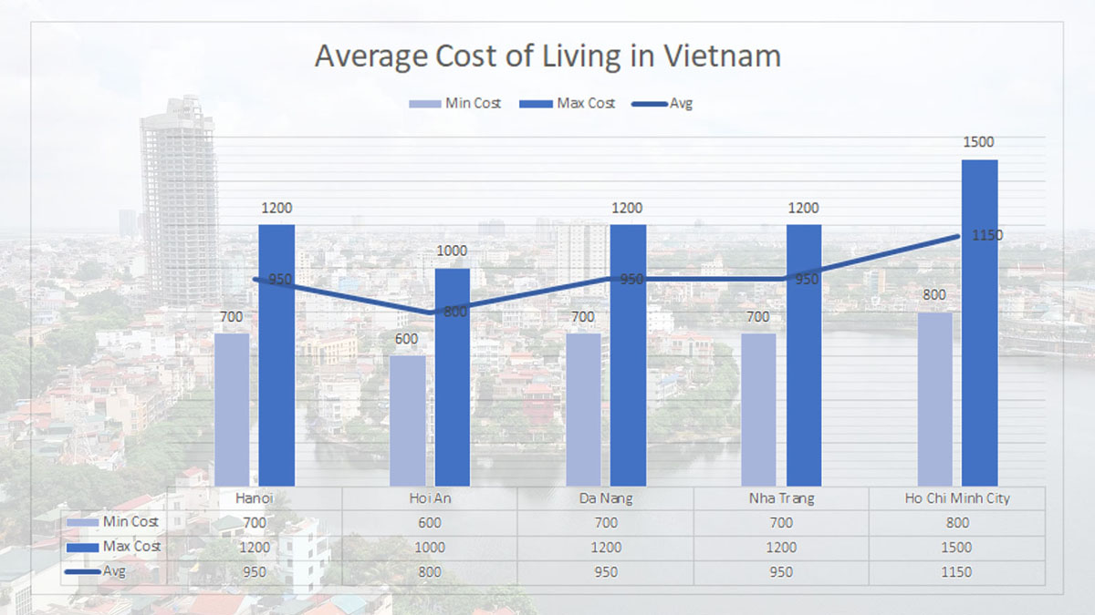

**Source: Asia Legend Travel**

### IT Salary

Offshore tech centers, especially in markets like Vietnam, can offer skilled talent at a fraction of the cost compared to Western countries. For example, the average salary for a software engineer in Hanoi, Vietnam is approximately $10,000 - $30,000 annually, compared to $105,000+ in the US. (Source: Levels.fyi).

The salary structure in Vietnam provides substantial savings compared to Western countries. 2024 marks the fourth consecutive year that Vietnam has been recognized as the most affordable country for expatriates, according to research and consulting firm InterNations.

According to data from TopDev.vn, a leading Vietnamese recruitment agency specializing in IT positions, the average monthly gross salaries for software developers in Vietnam are as follows:

* Junior level (<2 years of experience): $350 - $565
* Mid-senior level (2 - 4 years of experience): $535 - $1,190
* Senior level (>4 years of experience): $860 - $1,510

In Vietnam, a software developer's salary is not only influenced by their level of experience but also by the specific tech role they occupy, with specialized positions often commanding higher pay.

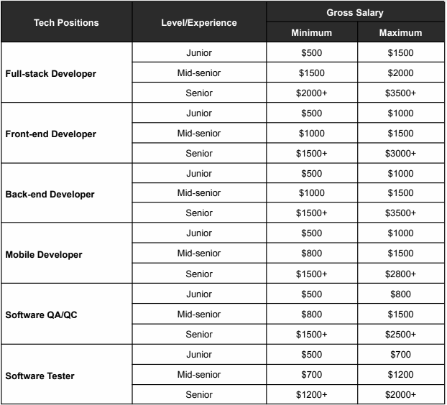

These wages offer a substantial cost advantage, especially when compared to U.S. tech salaries, where a software engineer can earn over $105,000 annually (Source: Levels.fyi)

To remain competitive and attract top-tier talent, companies may need to offer salaries that exceed local market norms. Drawing from our experience with global tech businesses, we suggest offering a salary premium of about 10-20% above the standard market rate to effectively compete for skilled professionals and ensure retention.

### Employee Benefits

Employers in Vietnam contribute to several mandatory benefits, including:

***Insurance contribution rate in 2024 of Vietnamese workers***

|  |  |  |  |  |  |  |  |  |  |
| --- | --- | --- | --- | --- | --- | --- | --- | --- | --- |
| **Employers** | | | | | **Employees** | | | | |
| Social Insurance | | | Unemployment Insurance | Health Insurance | Social Insurance | | | Unemployment Insurance | Health Insurance |
| Pension | SL & ML | OI & DI | Pension | SL & ML | OI & DI |
| 14% | 3% | 0.5% | 1% | 3% | 8% | - | - | 1% | 1.5% |
| 21.5% | | | | | 10.5% | | | | |
| Total: 32% | | | | | | | | | |

*\*SL & ML: Sick Leave & Maternity Leave*

*\*OI & DI: Occupational Injury & Disease Insurance*

Additionally, companies may offer performance bonuses, annual bonuses (typically one month’s salary), and other perks like healthcare or flexible working arrangements. These costs are relatively low compared to Western standards, making it an attractive option for businesses looking to expand without excessive overhead.

### Taxes

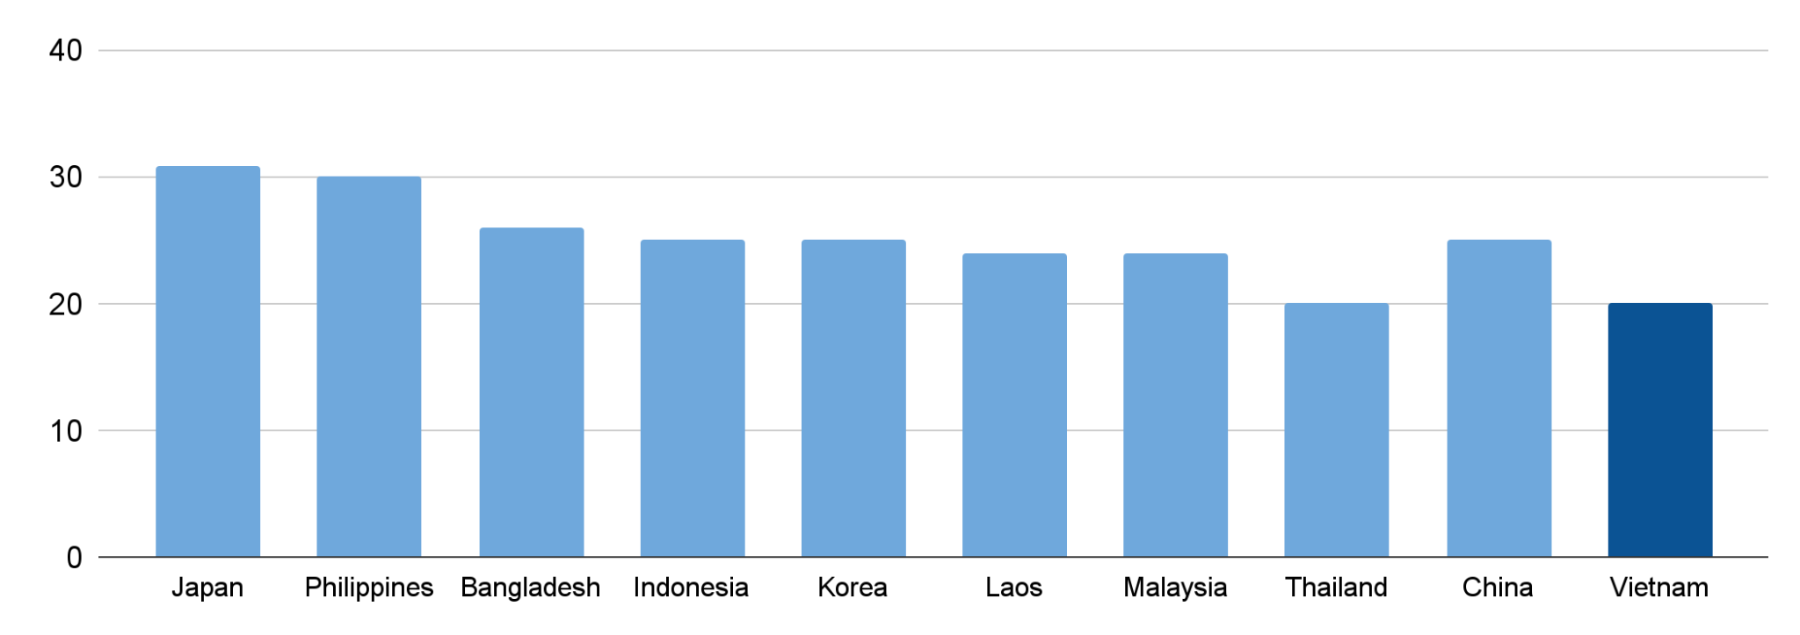

***Corporate income tax rates of some countries and territories in Asia (%)***

The standard VAT rate is 10% and corporate tax rate in Vietnam is 20%, which is competitive compared to many Western countries. However, companies in high-tech sectors or special economic zones may benefit from tax incentives, such as tax exemptions for the first 4 years and reduced rates for up to 9 years.

### Operational Infrastructure and Costs

**Office Space**

Vietnam offers a highly cost-effective environment for tech companies, with operational costs, including office space and utilities, typically 20 - 30% lower than in many Western countries (Source: Geniusee). This makes it an attractive destination for businesses looking to optimize costs while maintaining efficient operations.

Office rental costs in major tech hubs such as Ho Chi Minh City, Hanoi and Danang are particularly competitive:

* **Ho Chi Minh City**: $30 - $40/m²/month for Class A, $10 - $20/m²/month for general.
* **Hanoi**: $25 - $35/m²/month for Class A, $8 - $18/m²/month for general.
* **Da Nang**: $18 - $28/m²/month for Class A, $6 - $15/m²/month for general.

For smaller teams or startups,coworking spaces provide a highly affordable alternative, with rates starting at $15 - $30/m²/month for dedicated desks or private offices in all three cities.

**Technology Infrastructure**

* **Internet Speed**: High-speed internet plans in Vietnam typically cost $15 to $30 per month for business-grade connections with speeds ranging from 50 Mbps to 100 Mbps.
* **Server Access and Cloud Readiness**: Cloud hosting services start at $20 to $50 per month, with local data centers offering fast access to global cloud providers like AWS and Microsoft Azure.
* **Digital Infrastructure**: Renting server space in local data centers costs $300 to $1,000 per month depending on the location and service level.

**Support Services**

* **Legal Services:** Legal services in Vietnam cost around $100 - $200 per hour for corporate legal work provided by local law firms.
* **Accounting Services:** Accounting services typically cost $200 to $500 per month for small to mid-sized businesses.
* **HR Services:** Outsourced HR services, including payroll and recruitment, generally cost between $300 and $1,000 per month.

**Remote vs. In-Office Decisions**

* **Hybrid Models**: Hybrid work models allow businesses to reduce office space costs by 20-30% compared to traditional setups.
* **Local Remote Work Regulations**: Vietnam has no specific remote work regulations, but businesses may invest $10 to $30 per user per month for collaboration tools.

### Talent Acquisition and Workforce Management

In terms of workforce, Vietnam boasts a large labor pool with steadily improving quality that meets international standards, alongside highly competitive wages. These factors are key strengths attracting the attention of international investors in the information technology sector.

As of June 2024, the total number of workers in the industry is estimated at approximately 1,530,528, an increase of 1.3% compared to the same period last year. Of this, the software and IT services sector accounts for about 27%, equivalent to over 300,000 workers (Source: VINASA). Not only does Vietnam meet domestic demand, but the country is also striving to comprehensively develop its IT workforce to cater to the international market.

**Recruitment Channels and Processes**

In Vietnam, recruitment is often done through local job boards (Vietnamworks, TopCV) or specialized recruiting agencies ([JobSavvy](https://job-savvy.com/), HR2B Navigos Group). Additionally, Vietnam has a strong network of universities, which regularly partner with businesses to provide internship programs, job fairs and job placement opportunities for fresh graduates.

**Tech Talent Specializations and Quality**

Vietnam's IT industry has matured, boasting a large and highly skilled workforce recognized internationally. With extensive experience in executing IT projects for global markets, Vietnam ranks among the top 7 most attractive countries for IT service exports and has been Japan's second-largest IT outsourcing partner since 2014. Vietnamese IT professionals are noted for their rapid technological adaptability and are highly regarded for their expertise in emerging technologies.

Vietnamese engineers are among the few globally to earn prestigious certifications, such as advanced TensorFlow AI certifications from Google and Predix IoT certifications from GE. The number of engineers with Amazon AWS and Microsoft certifications is also growing rapidly.

According to HackerRank, Vietnamese programmers rank third globally in artificial intelligence by domain expertise. In general skills, Vietnam is ranked second among Southeast Asian nations and 23rd among the top 50 countries with the best programmers worldwide. Skillvalue places Vietnam at 29th in its Programmer Skills Ranking, making it the only Southeast Asian representative in the top 30.

In addition, Vietnam’s software development sector is ranked among the top 10 globally in terms of outsourcing destinations due to its strong technical expertise and English proficiency (Source: The 2023 Kearney Global Services Location Index).

**IT Workforce Training**

Vietnam currently has 236 universities, 149 of which offer IT programs, producing over 55,000 IT engineers annually. Additionally, 412 vocational colleges and secondary schools provide IT training, contributing approximately 20,000 skilled professionals to the industry each year. (Source: VINASA)

While public universities such as Hanoi University of Science and Technology, Vietnam National University - Ho Chi Minh City, and the Posts and Telecommunications Institute of Technology supply the majority of the workforce, private institutions like FPT University, Lac Hong University, Duy Tan University, and Le Quy Don School are also heavily investing in high-quality IT education.

Human resource development is a top priority in Vietnam's national digital transformation program. The government is implementing several initiatives to achieve its objectives, including:

* Annual enrollment and training of IT specialists, including bachelor's and master's programs, and vocational education focusing on digital technologies such as AI, data science, Big Data, Cloud Computing, IoT, VR/AR, Blockchain, and 3D Printing.
* Adoption of STEAM/STEAME models integrating science, technology, engineering, mathematics, arts, and business education.
* Digital skills training, upskilling, and reskilling for workers in industrial zones and export processing areas.
* Offering Massive Open Online Courses (MOOCs) to enhance public access to digital education, enabling nationwide upskilling and reskilling.
* Integrating technology education into primary school curricula to nurture digital literacy from a young age.

**Employee Retention**

The average annual turnover rate for IT employees in Vietnam is around 15% - 20%, according to a report by Navigos Group.

Besides salary, employees in Vietnam value comprehensive benefits packages that include healthcare insurance, annual leave, and performance-based bonuses. As the tech industry is growing, some companies offer additional perks like flexible working hours, remote work options, and employee development programs.

IT professionals in Vietnam seek companies that offer clear paths for career progression, skill development opportunities, and exposure to new technologies. Training programs, mentorship opportunities, and international collaboration are highly valued. Companies that invest in employees' personal and professional growth tend to retain talent longer.

### Language and Cultural Fit

**Communication Skills and Culture Dynamics**

Many Vietnamese tech professionals possess good English proficiency, especially in major cities like Ho Chi Minh City and Hanoi, ensuring that cultural alignment is in place is equally important. However, proficiency in other languages, such as Japanese, Korean, or French, is less common, which may require businesses to invest in IT comtors/translators or bilingual project managers and language courses to bridge the gap.

For culture dynamics in Vietnam, leadership and team dynamics are often influenced by a hierarchical work culture, where respect for authority and seniority plays a significant role. Leaders are generally expected to provide clear guidance and make decisions, and employees tend to defer to them for approvals or important decisions.

To bridge cultural differences effectively, educating both the headquarters and the local team on each other's cultural norms and approaches to decision-making is essential. Regular cultural exchange activities, virtual meetups, and providing space for open discussions can be key steps to ensure both teams feel understood and respected.

**Remote Communication**

* **Overlapping Work Hours**: Vietnamese teams typically work from **8 AM to 5 PM (GMT+7)**, so establishing core hours for overlap with HQ ensures real-time collaboration.
* **Regular Check-Ins**: Daily stand-ups or weekly meetings via **Zoom, Google Meet** or **Microsoft Teams** help keep teams aligned and address issues promptly.
* **Collaboration Tools**: Tools like **Slack**, **Trello**, and **Jira** are essential for asynchronous communication and task tracking.

**Timezone Adaptation**

Offshore centers in Vietnam enable round-the-clock operations by leveraging time zone differences. For example, US-based companies with teams in Vietnam can ensure continuous work progress, even outside US working hours. Another way is adopting a "follow-the-sun" model that can improve project timelines by 67% and enhance customer satisfaction through faster response times.

However, Vietnam's GMT+7 time zone can pose challenges for companies in the Western Hemisphere, especially those using agile development models that rely heavily on real-time interactions and quick responses.

### Typical ODC Models and Roles

**ODC Models**

Here are common models for setting up ODC in Vietnam. Each model provides varying levels of control, flexibility, cost-effectiveness, and risk management, making them suitable for different types of projects and business needs.

**Managed ODC model** and **Build – Operation – Transfer (BOT) model** are currently considered the most popular options.

|  |  |  |  |  |
| --- | --- | --- | --- | --- |
| **Model** | **Definition** | **When to choose?** | **Component** | **Benefits** |
| **Build-Operate-Transfer (BOT) Model** | * In this model, a partner helps you set up and operate an ODC for a specified period, after which the center is transferred to you, fully operational and self-managed. * This model is particularly useful when entering a new market and unfamiliar with local business practices. | * You need a partner to help establish the ODC and oversee operations during the setup phase. * You are unfamiliar with Vietnam's legal and regulatory requirements. | * **Setup Costs**: Moderate to high, as the partner handles operations initially. * **Transition Costs**: Additional expenses during the transfer phase. * **Operational Costs**: Managed by the partner initially, with increasing self-management costs later. * **Overall**: Ideal for phased investment with initial support. | Risk mitigation, smoother market entry, and local expertise during the setup phase. |
| **Managed Services Model** | * In the managed services model, a third-party service provider manages the day-to-day operations of your ODC, from recruitment to project management. * The provider ensures that the ODC runs smoothly and that all tasks are completed according to the client’s specifications. | * You prefer to focus on core business activities while outsourcing operational management. * You want to minimize the risk of managing a team in a foreign country. | * **Service Fees**: Fixed or variable costs based on the provider’s management services. * **Setup Costs**: Minimal, as the service provider handles initial setup. * **Operational Costs**: Paid as part of the service agreement. * **Overall**: Cost-effective for companies prioritizing operational ease. | Reduced operational burden, expert management, and access to a well-established support network. |

**Typical ODC Roles**

The ODC team structure varies for specific projects. But the typical attributes of an offshore software development team include:

* **Project manager**: Managing the progress, reporting to the clients, and is the contact point between the client and the team.
* **Technical leader**: Takes charge of the technical terms of the project and ensures the outcome meets the Software Requirements Specification (SRS).
* **Business analyst**: Works directly with the client to analyze requirements and ensures the product meets the set bar in terms of functional and market requirements.
* **Developers**: Construct, deploy, and maintain software applications.
* **QA engineers and testers**: Ensure the software is bug-free and meets quality standards.
* **UI/UX designer**: Visualize the software and ensure user-friendly interfaces and experience.

### Service Level Agreements (SLAs)

Service Level Agreements (SLAs) are a critical part of outsourcing and offshore development agreements in Vietnam, ensuring clarity and accountability between companies and their local partners. Here are key aspects of SLAs in the Vietnamese context:

**Performance Metrics**

* Clearly define expected outcomes, such as uptime (e.g., 99.9% availability for IT services), resolution times, and development milestones.
* Use specific Key Performance Indicators (KPIs) tailored to project needs, like defect rates or time-to-market goals.

**Quality Assurance**

* SLAs often include adherence to international standards like ISO 9001 and CMMI Level 3+ for software quality.
* Regular audits and reporting cycles ensure quality benchmarks are maintained.

Vietnamese IT companies adhere to globally recognized standards and certifications to ensure quality and reliability. Commonly implemented standards include:

* **ISO 9001**: For quality management systems.
* **ISO/IEC 27001**: For information security management.
* **CMMI (Capability Maturity Model Integration)**: For process improvement and product development.
* **GDPR Compliance**: Ensuring data privacy and protection for European clients.

Additionally, Vietnamese ODCs prioritize robust quality assurance (QA) processes, incorporating:

* Automated and manual testing to ensure functional and non-functional requirements are met.
* Continuous integration/continuous delivery (CI/CD) pipelines to maintain product stability.
* Comprehensive reporting and transparency during the development lifecycle.

According to NASSCOM, over 70% of offshore vendors in Vietnam and India implement these standards, enabling seamless integration with global business requirements and fostering trust among international clients.

**Compliance and Security**

* Include provisions for compliance with local regulations and international standards, such as GDPR for data protection.
* Specify IP rights protection and confidentiality clauses to safeguard sensitive information.

For data security, Vietnamese IT firms implement strict protocols, including:

* Secure development environments with access control measures.
* Encryption and secure communication channels.
* Regular audits and penetration testing to identify vulnerabilities.

This focus on cybersecurity ensures that businesses partnering with Vietnamese ODCs can confidently manage sensitive information.

**Support and Maintenance**

* Define support levels, including response and resolution times for technical issues (e.g., Tier 1, Tier 2 support timelines).
* Include post-launch support for software projects to ensure ongoing performance.

**Penalties and Incentives**

* Establish penalties for non-compliance, such as financial reimbursements for service downtime or delays.
* Introduce performance incentives for exceeding SLA targets to encourage better outcomes.

**Cultural and Communication Considerations**

* Account for time zone differences and communication practices, ensuring overlaps in working hours or agreed response times.
* Include clauses for regular check-ins and updates via tools like Slack, Zoom, or Jira to track progress.

## Financial Planning and ROI Analysis

**Budgeting for Offshore Centers**

A comprehensive budget must account for various aspects of establishing and running an ODC. Below are the major cost factors:

|  |  |  |  |
| --- | --- | --- | --- |
| **Cost Category** | | **Description** | **Estimated Costs** |
| **Recruitment Costs** | Hiring Costs | Expenses for using local job boards, recruitment agencies, or university partnerships. | $200 - $500 per hire, depending on the role and hiring method. |
| Onboarding and Training | Initial costs for equipping employees with the tools and knowledge required to align with company objectives. | $500 - $1,000 per employee for training sessions and tools. |
|  | IT professionals in Vietnam typically expect salaries in line with market standards, along with mandatory benefits such as insurance, leave policies, and bonuses. | $800 - $2,500 per month per employee. |
| **Infrastructure Costs** | Office Space | Costs range based on the location and quality of facilities. | $15 - $30 per square meter/month (varies by location). |
| IT Infrastructure | Investment in hardware, software licenses, and network setup to ensure productivity and security. | $5,000 - $15,000 for initial setup. |
| Utilities and Maintenance | Regular expenses for electricity, internet, water, and facility upkeep. | $500 - $1,200 per month. |
| **Legal and Compliance Costs** | Company Incorporation | Fees for registering the business and obtaining necessary permits. | $1,000 - $3,000 (one-time fee). |
| Consulting Fees | Engagement with legal and accounting firms to navigate Vietnam's regulatory environment. | $100 - $200 per hour (varies by firm). |
| Mandatory Contributions | Compliance with local labor laws, including social insurance, health insurance, and unemployment insurance contributions. | 20-25% of employee salaries per month. |
| **Operational Costs** | Day-to-Day Management | Salaries for administrative staff, operational oversight, and team leaders. | $1,200 - $3,000 per month for admin and management roles. |
| Employee Engagement | Initiatives to maintain morale and productivity, such as team-building activities and wellness programs. | $1,000 - $3,000 per quarter. |
| Miscellaneous Costs | Unforeseen expenses related to scaling or adapting to market changes. | $500 - $2,000 (variable based on specific needs). |

*Note: The values marked with variables would be specific to the company and its location in Vietnam. You would need to gather data or estimates specific to your situation to fill these values in for more accurate financial planning.*

**Calculating ROI**

To measure the effectiveness of the ODC, businesses need to focus on clear metrics.

**Key Metrics**

* **Cost Savings**: Compare costs in Vietnam against the parent company’s home country to quantify direct savings. For example, IT salaries in Vietnam are generally 40-60% lower than in Western countries.
* **Productivity Improvements**: Track the efficiency of the ODC in terms of output, deadlines met, and quality of deliverables.
* **Impact on Product Timelines**: Leverage Vietnam’s time zone advantage for faster development cycles, ensuring quicker time-to-market.

**ROI Calculation Framework**

* **Total Investment**: Initial setup costs + operational expenses over a defined period.
* **Net Revenue**: Project revenue minus operational expenses.

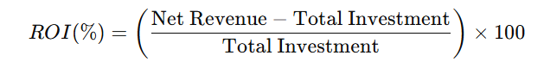

**Break-even Analysis**

The break-even point is when the cumulative savings and gains from the ODC equal the initial investment and ongoing costs.

**Steps to Determine Break-even**

* **Calculate Total Costs**: Sum up initial setup costs (e.g., recruitment, infrastructure, legal fees) and ongoing monthly costs (e.g., salaries, rent).
* **Estimate Monthly Savings**: Determine cost differences in salaries, operational expenses, and time-to-market benefits.
* **Determine the Break-even Period**: Divide the total costs by monthly savings to find the number of months required to break even.

**Example**

* **Initial Setup Costs**: $300K
* **Monthly Operating Costs**: $50K
* **Monthly Savings**: $75K
* **Break-even Period**:



## Checklist for Offshore Setup

To establish a successful offshore tech center, follow these actionable steps:

**✓ Define Clear Objectives**: Identify the core purpose of the business offshore center such as primary goals, cost optimization, market entry, or innovation hub creation.

**✓ Location Analysis**: Evaluate locations based on talent pool size, salary benchmarks, language proficiency, and time-zone compatibility. For example, major cities such as Ho Chi Minh City, Da Nang or Hanoi in Vietnam are highly rated for tech skills and cultural alignment.

**✓ Regulatory Preparedness**: Understand national employment laws, data privacy regulations, and tax obligations. For instance, Vietnam provides corporate tax exemptions in high-tech zones, creating an attractive environment for global tech investments.

**✓ Talent Acquisition Plan**: Partner with local recruitment agencies, leverage university programs, and use diverse recruitment platforms for sourcing talent. Develop a competitive benefits package to attract top talent, including health insurance, flexible work policies, and career development opportunities.

**✓ Operational Setup**: Choose between coworking spaces, leased offices, or BOT (Build-Operate-Transfer) models. For locating companies in Vietnam, coworking spaces might provide more flexibility for new entrants.

**✓ Cultural Integration:** Implement targeted cross-cultural training and establish clear communication protocols to foster seamless collaboration. Leveraging CRM tools for regular check-ins and scheduling overlapping work hours can significantly enhance team dynamics.

**✓ Performance Monitoring**: Use KPIs such as time-to-market, cost efficiency, and employee retention to measure success. For offshore centers, achieving a 20% cost reduction within 2 years is a common benchmark.

**✓ Leverage Local Expertise:** Engage local advisors and industry experts to gain deep insights into cultural nuances, business practices, and regulatory landscapes, ensuring smoother operations and stronger stakeholder relationships. Additionally, participating in local business networks, such as trade associations or tech forums, can provide valuable connections and up-to-date market intelligence to optimize your offshore strategy.

## Leading IT Companies Providing ODC Services in Vietnam

|  |  |  |  |  |  |
| --- | --- | --- | --- | --- | --- |
| **Company** | **Specialization** | **Industries Served** | **Global Presence** | **Key Services** | **Notable Strengths** |
| **FPT Software** | Custom software development, IT consulting, digital transformation | Banking, Finance, Healthcare, Telecom, Retail | USA, Europe, Japan, etc. | Software development, IT consulting, testing, managed services | Largest IT outsourcing company in Vietnam, large-scale projects, end-to-end services |
| **Savvycom Software** | Software development, mobile app development, IT consulting | Banking, Healthcare, Retail, Education, Manufacturing | USA, Australia, Korea, Thailand, Japan, Singapore | Global delivery center services, dedicated development team, custom software development, IT consulting, mobile development, digital solutions | Known for high-quality custom development, focus on innovation, personalized services and solutions |
| **KMS Technology** | Software development, digital transformation, IT consulting | Healthcare, Finance, Retail, Manufacturing | USA, Vietnam | Full-cycle software development, testing, digital transformation | Strong expertise in DevOps, Agile methodology, and high-quality testing |
| **CMC Global** | IT outsourcing, software development, cloud services | Finance, Healthcare, Retail, Telecom | USA, Asia | Offshore development, IT consulting, cloud solutions, systems integration | Backed by the CMC Group, offers a broad range of IT solutions, strong in security and infrastructure |

These companies are among the top IT providers for ODC services in Vietnam, each with distinct strengths and approaches to creating value. Take [Savvycom](https://savvycomsoftware.com/) as an example - their unique selling point in ODC services lies in a strategic blend of deep industry expertise, personalized client engagement, and innovative delivery models. With global offices in the USA, Australia, Thailand, Korea, Japan, and Singapore, Savvycom leverages local experts to bridge cultural and operational gaps, ensuring seamless collaboration and tailored solutions for clients worldwide. The company enables clients to operate [Global Delivery Centers](https://savvycomsoftware.com/services/global-delivery-center/) through flexible service offerings like [Dedicated Development Teams](https://savvycomsoftware.com/services/dedicated-software-development-team/) and diverse engagement models, such as [Team-based](https://savvycomsoftware.com/services/team-based-development-services/) or [Project-based](https://savvycomsoftware.com/services/project-based-development-services/) approaches.

***Ms. Van Dang - CEO of Savvycom*** has shared that “[NVIDIA's $4 billion investment in Vietnam in the next 4 years](https://morstar.vn/nvidia-has-signed-an-agreement-to-move-its-production-chain-from-other-countries-to-vietnam-committing-to-invest-4-4-5-billion-usd-in-the-next-4-years/#:~:text=Specifically%2C%20NVIDIA%20has%20signed%20agreements,jobs%20in%20the%20coming%20years) highlights the country as a highly competitive destination for global technology companies”. This growing interest from major players reinforces the potential of Vietnam as a hub for offshore development centers (ODCs), offering businesses access to top-tier talent, cutting-edge innovation, and a conducive environment for scaling operations. Additionally, Ms. Van also highlights that the company’s offshore development center (ODC) services are a key part of Savvycom’s strategy to provide businesses with tailored, scalable solutions, leveraging Vietnam’s growing tech talent and its strategic position for global expansion.

Offshore expansion, when executed strategically, is a powerful tool for companies to stay ahead in the global marketplace. As the industry continues to evolve, it is a competitive advantage for businesses looking to expand. By aligning with emerging trends, leveraging the right resources, and maintaining a focus on cultural and operational alignment, your offshore center can become a cornerstone of innovation, scalability, and long-term success. Vietnam, with its competitive advantages, provides an ideal environment for companies looking to foster sustainable growth and lead in the digital era. Whether through the innovation-driven atmosphere of Hanoi, the commercial power of Ho Chi Minh City, or the growing tech sector in Da Nang, Vietnam offers diverse opportunities for growth.